AP Environmental Science
Midterm Review

Name: _____________________________________________________________________________ Period: 8 Date: 1/17/14

Colorado River Drought Forces a Painful Reckoning for States

By MICHAEL WINES JAN. 5, 2014
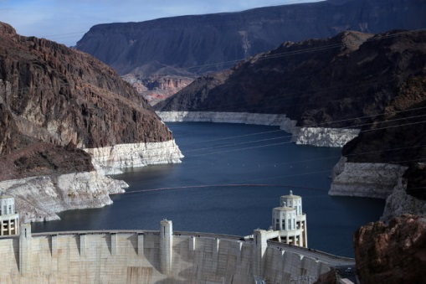
LAKE MEAD, Nev. — The sinuous Colorado River and its slew of man-made reservoirs from the Rockies to southern Arizona are being sapped by 14 years of drought nearly unrivaled in 1,250 years.
The once broad and blue river has in many places dwindled to a murky brown trickle. Reservoirs have shrunk to less than half their capacities, the canyon walls around them ringed with white mineral deposits where water once lapped. Seeking to stretch their allotments of the river, regional water agencies are recycling sewage effluent, offering rebates to tear up grass lawns and subsidizing less thirsty appliances from dishwashers to shower heads.
But many experts believe the current drought is only the harbinger of a new, drier era in which the Colorado’s flow will be substantially and permanently diminished.
Faced with the shortage, federal authorities this year will for the first time decrease the amount of water that flows into Lake Mead, the nation’s largest reservoir, from Lake Powell 180 miles upstream. That will reduce even more the level of Lake Mead, a crucial source of water for cities from Las Vegas to Los Angeles and for millions of acres of farmland.
Reclamation officials say there is a 50-50 chance that by 2015, Lake Mead’s water will be rationed to states downstream. That, too, has never happened before.
“If Lake Mead goes below elevation 1,000” — 1,000 feet above sea level — “we lose any capacity to pump water to serve the municipal needs of seven in 10 people in the state of Nevada,” said John Entsminger, the senior deputy general manager of the Southern Nevada Water Authority.
Since 2008, Mr. Entsminger’s agency has been drilling an $817 million tunnel under Lake Mead — a third attempt to capture more water as two higher tunnels have become threatened by the lake’s falling level. In September, faced with the prospect that one of the tunnels could run dry before the third one was completed, the authority took emergency measures: still another tunnel, this one to stretch the life of the most threatened intake until construction of the third one is finished.
These new realities are forcing a profound reassessment of how the 1,450-mile Colorado, the Southwest’s only major river, can continue to slake the thirst of one of the nation’s fastest-growing regions. Agriculture, from California’s Imperial Valley to Wyoming’s cattle herds, soaks up about three-quarters of its water, and produces 15 percent of the nation’s food. But 40 million people also depend on the river and its tributaries, and their numbers are rising rapidly.
The labyrinthine rules by which the seven Colorado states share the river’s water are rife with potential points of conflict. And while some states have made huge strides in conserving water — and even reducing the amount they consume — they have yet to chart a united path through shortages that could last years or even decades.

1. At a certain depth, the area where the spaces in soil and rock are completely filled with water is called
- the zone of saturation (D) surface water
- the water table (E) the bedrock
- an aquifer

2. The geological layer, consisting of underground caverns and porous layers of sand, gravel, or bedrock, where groundwater flows, is called
- the zone of saturation (D) surface water
- the water table (E) the bedrock
- an aquifer

3. The term subsidence refers to
- failure of the groundwater supply
- sinking of ground due to water overdraft
- living on very little money
- intrusion of salt water into a freshwater aquifer
- money paid by the government to farmers

4. Which of the following is NOT a solution to domestic water use conservation?
- Low flow showerheads and faucets
- Use of recycled water (grey) for watering of lawns
- Charge a flat fee for water use instead of using meters
- Replace lawn with native plants that need little irrigation
- Flush toilets only when necessary

5. Withdrawing too much water from an aquifer can cause all of the following except
- droughts
- land subsidence
- sinkholes
- freshwater contaminated with saltwater
- making aquifers impossible to recharge

6. Which of the following is the most efficient means of water delivery to crops?
- center-pivot sprinkler systems
- low-energy precision-application (LEPA) sprinkler systems
- trickle or drip irrigation
- gravity-flow canal systems
- diagonal-pivot systems

7. Four of the following are disadvantages of dam and reservoir systems; one is not. Choose the one that is not.
- disrupts migration of some fish
- displaces people behind the dam
- leads to devastating flooding if there is a failure
- reduces water loss through evaporation
- reduces nutrients released downstream

8. Saudi Arabia gets 70% of its drinking water from
- Deep aquifers (D) Desalinization
- Water imports (E) Lakes
- Dammed rivers

QUESTION #2 FROM 2002 APES FRQ SECTION
The Colorado River runs 1,450 miles from the headwaters of the Rocky Mountains to the Gulf of California. The river has many dams, aqueducts, and canals that divert water in order to supply water for electricity, irrigation, recreation, and domestic use.
- Describe and discuss two environmental problems that are associated with water diversion.
- If there is a shortage of water, choices will have to be made as to whether water should be diverted to urban areas, agricultural areas, or natural ecosystems. Make an argument for diverting water for urban consumption and an argument for permitting the flow of water to natural area.
- Identify another example (other than the Colorado River) of a large-scale water-diversion project. Discuss two environmental problems that have resulted, or might result, from this project.
______________________________________________________________________________________________________________________________________________________________________________________________________________________________________________________________________________________________________________________________________________________________________________________________________________________________________________________________________________________________________________________________________________________________________________________________________________________________________________________________________________________________________________
__________________________________________________________________________________________________________________________________________________________________________________________________________________________________________________________________________________________________________________________________________________________________________________________________________________________________________________________________________________________________________________________________________________________________________________________________________________________________________________________________________________________________________________________________________________________________________________________________________________________________________________________________________________________________________________
____________________________________________________________________________________________________________________________________________________________________________________________________

