Water Cycle Video

- Does water stay permanently in water stores or reservoirs? Why or why not?

- How does water return to the atmosphere?

Water Cycle Worksheet

Directions: For each of the numbers below, identify the part of the water cycle. Then list the phase change of water (if there is a phase change). Finally, describe the other spheres that are involved in the process in COMPLETE SENTENCES. Finally, answer the challenge questions below.
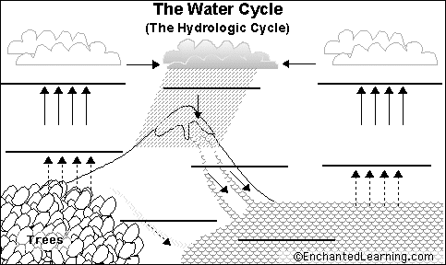
5.
4.
4.
6.
6.
1.
3.
2.

1. ________________________

2. ________________________

- Phase change:

- Interacting Spheres:

3. ________________________

- Phase change:

- Interacting spheres:

4. ____________________

- Phase change:

- Interacting spheres:

6.____________________

5. ____________________

- Phase change:

- Interacting spheres:

Questions:
- In which process of the water cycle are the most spheres interacting?

2) How could pollution in the atmosphere affect the water cycle?

