Unit 6 Review: More Humans, More Problems
Total Fertility Rate Human Population Control Methods Infant mortality rate Population Pyramids Survivorship Curves China’s one child policy Tragedy of the Commons

Directions: Answer the following questions in COMPLETE sentences.

- Why does total fertility rate tend to be higher in developing countries?

- What are two causes of exponential human population growth?

- How can raising the status of women be a method of population control?

- What are two advantages and two disadvantages of human population control?

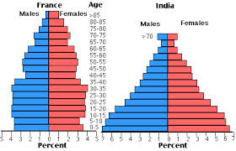v

- Which country has the highest population growth rate? Which has the lowest? How do you know based on the population pyramid?

- How is a type II survivorship curve different than a type III survivorship curve?

- How is traffic congestion an example of tragedy of the commons?

