Environmental Science Unit 3 Exam Review

Key Terms

Ecosystem Community Population Species Autotroph Heterotroph
Ecological Niche Parasitism Commensalism Mutualism Competitive Exclusion Principle Pyramid of Numbers Pyramid of Energy Decomposer Biotic Factors Abiotic Factors Predation Herbivores Carnivores Omnivores

- How is an ecosystem different from a community?

- Oxpeckers land on rhinos or zebras and eat ticks and other parasites that live on their skin. The oxpeckers get food and the beasts get pest control. Also, when there is danger, the oxpeckers fly upward and scream a warning. What type of symbiosis relationship is this? Why?

- How is a heterotroph different from an autortroph?

- How is commensalism different from parasitism?

- How does the competitive exclusion principle relate to ecological niches?

Key Terms

Density Dependent Limiting Factor Density Independent Limiting Factor Population Growth Logistic Growth Linear Growth Carrying Capacity Immigration Emigration
Primary Succession Secondary Succession Keystone Species

- Imagine a population of skunks outside UASCJ that is growing at a rapid pace. List one density dependent factor that could limit the skunk’s population growth rate.

- List one density independent factor that could limit the skunk’s population growth rate.

3) Which type of population growth is present with a population that reaches carrying capacity?

4) Label each type of population growth

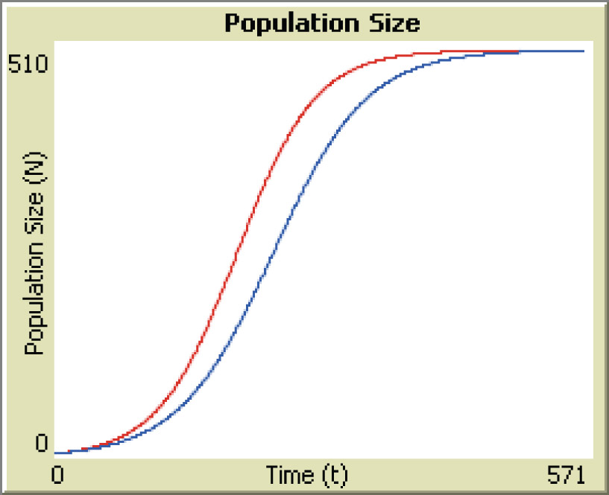
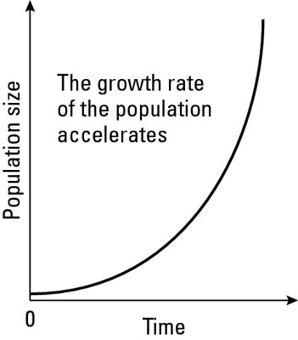
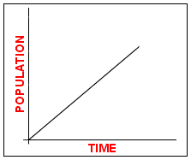

5) What is a climax community?

- How is primary succession different from secondary succession?

