Energy Flow between Trophic Levels
Directions: Answer all of the questions in COMPLETE sentences.
ENGAGE: In your group, construct your own food web using the images on the cards on the table in front of you.

EXPLORE: In your group, use the test tubes in front of you to predict how much energy gets transferred from one organism to the next in an ecosystem.
- You will start with 100ml of energy (liquid) in one of the test tubes. Pour liquid from one test tube to the others in order to show how much energy your group thinks gets transferred between trophic levels.
- Use the food chain you created in the ENGAGE to label each test tube.
- In the chart below, estimate how much liquid (mL) you have for each test tube.
Autotroph | Herbivore | Carnivore
Provide a reason for why you have the amounts of liquid in each test tube that you chose.

MOVE THE TEST TUBES OFF TO THE SIDE SO THAT THEY WILL NOT GET KNOCKED OVER. YOU WILL NEED THEM LATER ON.

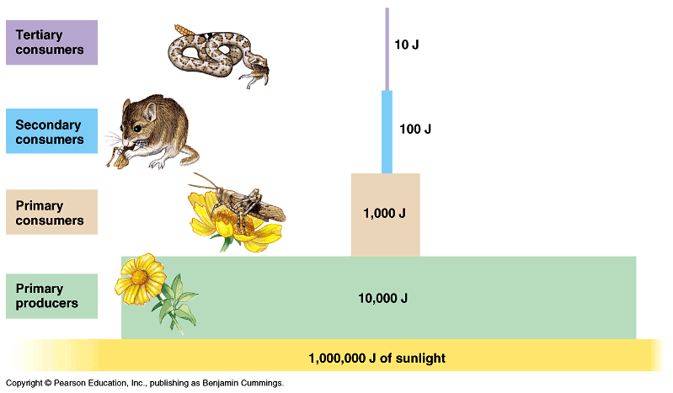

J = Joules (unit of energy)

1) The image above represents, on average, how much energy gets transferred from one trophic level to the next. This pyramid is called a pyramid of energy. Write a trend that relates trophic levels to energy:

2) What is one rule you could make for make for energy transfer?

3) What do you think happens to the energy that is not passed on to each trophic level?

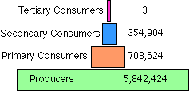

4) The Image above is called a pyramid of numbers. Write a trend that relates the trophic level to the number of organisms.

5) Why do you think there are less animals in the higher trophic levels? (hint: think about energy)

