The Simpsons and The Scientific Method

Directions: Read each situation and identify the dependent and independent variable.
- Smithers thinks that a special juice will increase the productivity of workers. He creates two groups of 50 workers each and assigns each group the same task (in this case, they're supposed to staple a set of papers). Group A is given the special juice to drink while they work. Group B is not given the special juice. After an hour, Smithers counts how many stacks of papers each group has made. Group A made 1,587 stacks, Group B made 2,113 stacks.
Independent variable:
Dependent Variable:
Testable Question:
Hypothesis:

2) Homer notices that his shower is covered in a strange green slime. His friend Barney tells him that coconut juice will get rid of the green slime. Homer decides to check this out by spraying half of the shower with coconut juice. He sprays the other half of the shower with water. After 3 days of "treatment" there is no change in the appearance of the green slime on either side of the shower.
Independent variable:
Dependent Variable:
Testable Question:
Hypothesis:

3) Bart believes that mice exposed to microwaves will become extra strong (maybe he's been reading too much Radioactive Man). He decides to perform this experiment by placing 10 mice in a microwave for 10 seconds. He compared these 10 mice to another 10 mice that had not been exposed. His test consisted of a heavy block of wood that blocked the mouse food. He found that 8 out of 10 of the microwaved mice were able to push the block away. 7 out of 10 of the non-microwaved mice were able to do the same.
Independent variable:
Dependent Variable:
Testable Question:
Hypothesis:

4) Krusty was told that a certain itching powder was the newest best thing on the market; it even claims to cause 50% longer lasting itches. Interested in this product, he buys the itching powder and compares it to his usual product. One test subject (A) is sprinkled with the original itching powder, and another test subject (B) was sprinkled with the Experimental itching powder.
Subject A reported having itches for 30 minutes. Subject B reported to have itches for 45 minutes.
Independent variable:
Dependent Variable:
Testable Question:
Hypothesis:

5) Lisa is working on a science project. Her task is to answer the question: "Does Rogooti (which is a commercial hair product) affect the speed of hair growth". Her family is willing to volunteer for the experiment.
Independent variable:
Dependent Variable:
Testable Question:
Hypothesis:

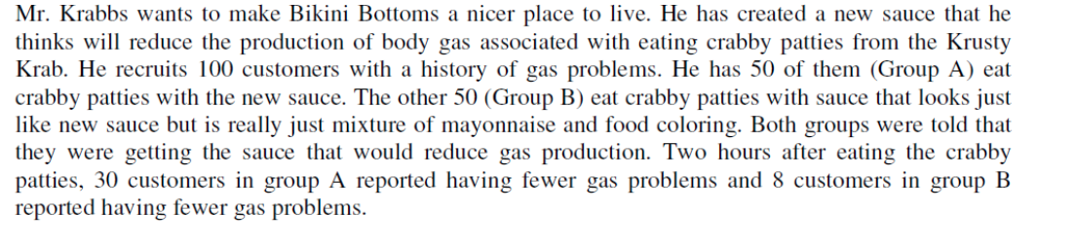
Independent variable:
Dependent Variable:
Testable Question:
Hypothesis:

