The Power of the Pyramids

Introdutcion: The 2000 growth rate of 1.4 percent, when applied to the world's 6.1 billion population, yields an annual increase of about 85 million people. Because of the large and increasing population size, the number of people added to the global population will remain high for several decades, even as growth rates continue to decline.
Between 2000 and 2030, nearly 100 percent of this annual growth will occur in the less developed countries in Africa, Asia, and Latin America, whose population growth rates are much higher than those in more developed countries. Growth rates of 1.9 percent and higher mean that populations would double in about 36 years, if these rates continue. Demographers do not believe they will. Projections of growth rates are lower than 1.9 percent because birth rates are declining and are expected to continue to do so. The populations in the less developed regions will most likely continue to command a larger proportion of the world total. While Asia's share of world population may continue to hover around 55 percent through the next century, Europe's portion has declined sharply and could drop even more during the 21st century. Africa and Latin America each would gain part of Europe's portion. By 2100, Africa is expected to capture the greatest share.

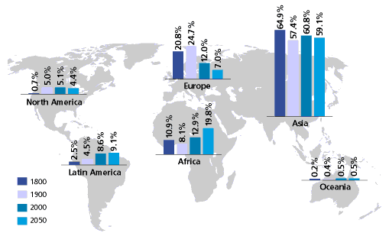

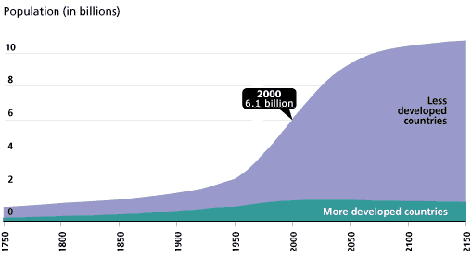

Procedure:
Country:_____________________

- Research the following information for your country:
  - TFR:___________________

  - Infant Mortality Rate:___________________

  - Life expectancy:_______________________

  - Area of the country:____________________________

- Go to www.census.gov
  - Click on US and World Population Clock >> click on World >> search for your country and click on it on the map. Write down the following information:

    - Population size:________________________

    - People per Square mile:_______________________

    - Projected population in 2050:_____________________

- Create a histogram for your country using the following steps:
  - Perform percentage calculations for each age category. Divide each age category population by the total population of that country.
  - Create a histogram of the data on the graph paper.

Post Lab Questions:

- What did your country’s histogram look like? Did either population have a baby boom? How could you account for the histogram’s shape?

- Determine the percentage of population that has yet to reach childbearing age. What does this number tell you about future growth in your countries?

- Determine the percentage of population that has yet to reach childbearing age. What does this number tell you about future growth in your countries?

