Layers of the Atmosphere

Background:
The atmosphere can be divided into four layers based on temperature variations. The layer closest to the Earth is called the troposphere. Above this layer is the stratosphere, followed by the mesosphere, and then the thermosphere. The upper boundaries of these layers are known as the tropopause, the stratopause, and the mesopause.
Temperature variations in the four layers are due to the way solar energy is absorbed as it moves downward through the atmosphere. The Earth’s surface is the primary absorber of solar energy. Some of this energy is reradiated upward by the Earth as heat, which warms the overlying troposphere. The global average temperature in the troposphere where all important weather phenomena occur rapidly decreases with altitude until reaching the tropopause.

Directions:
1. Table 1 contains the average temperature readings at various altitudes in the Earth’s atmosphere. Plot this data on the graph and connect adjacent points with a smooth curve. Be careful to plot the negative temperature numbers correctly. This profile provides a general picture of temperature at any given time and place; however, actual temperatures may deviate from the average values, especially in the lower atmosphere.
2. Label the layers of the atmosphere (troposphere, stratosphere, mesosphere, and thermosphere) and the separating boundaries (tropopause, stratopause, and mesopause) between each layer

Temperature (C) | Altitude (km)
15 | 0
-18 | 5
-49 | 10
-56 | 12
-56 | 20
-51 | 25
-46 | 30
-37 | 35
-22 | 40
-8 | 45
-2 | 48
-2 | 52
-7 | 55
-17 | 60
-33 | 65
-54 | 70
-65 | 75
-79 | 80
-86 | 84
-86 | 92
-81 | 95
-72 | 100
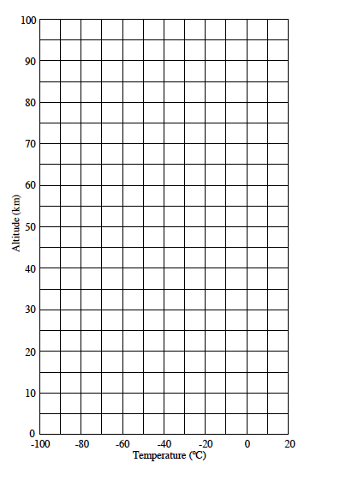
Layers of the Atmosphere

Directions: Answer the following questions in COMPLETE sentences.

- What is the basis for dividing the atmosphere into four layers?

2. Does the temperature increase or decrease with altitude in the:
troposphere _______________ stratosphere _______________
mesosphere _______________ thermosphere _______________

- Which layer is the farthest away?

- Which atmospheric layer contains the coldest temperatures?

- Which atmospheric layer has the highest temperatures?

6. Approximately how thick is the Earth’s atmosphere?

7. Which layer(s) contains the ozone layer?

8. What happens to the temperature at the tropopause?

9. Which layer contains clouds, wind, rain, snow and most weather patterns?

