Soil MC Practice

1. Which of the following best describes soils in
many tropical rain forests?
A) They lack soil horizons
B) They are quickly depleted of nutrients when the forest is removed
C) They are similar to soils in grasslands
D) They are well suited for growing a wide variety of crops
E) They are deep and well drained
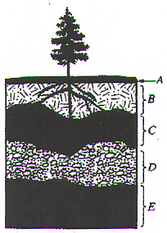

2. Which of the lettered choices in the soil profile
above represents the region with the greatest
concentration of organic material?
A) A
B) B
C) C
D) D
E) E

3. Which of the following is the correct order of
horizons in a soil profile?
A) A, B, C, D, O
B) O, E, C, B, A
C) O, A, E, B, C
D) A, E, C, B, O
E) E, O, A, B, C

4. Which type of soil consists of very fine particles
that make permeability of water low?
A) Clay
B) Gravel
C) Loam
D) Sand
E) Silt

5. Which type of soil allows water to permeate too
quickly for most crops to use?
A) Clay
B) Gravel
C) Loam
D) Sand
E) Silt

6. Soil conservation practices include all of the
following EXCEPT:
A) alley cropping
B) terracing
C) crop resting
D) crop rotation
E) removing nitrogen

7. The use of plants to clean up polluted soil is
known as
A) dilution
B) vapor extraction
C) bioremediation
D) phytoremediation
E) none of the above

- Which of the following types of soil listed below contains the highest amount of nutrients?
  - Clay
  - Silt
  - Sand
  - Gravel
  - Loam

- The Dust Bowl of the 1930s resulted in the passage of what legislation?
  - Endangered American Wilderness Act
  - Soil and Water Conservation Act
  - Federal Land Management Act
  - Public Rangelands and Improvement Act
  - Soil Erosion and Conservation Act

- The formation of soil is influenced by all of the following EXCEPT
  - Time
  - Climate
  - Parent material
  - Slope
  - Farming
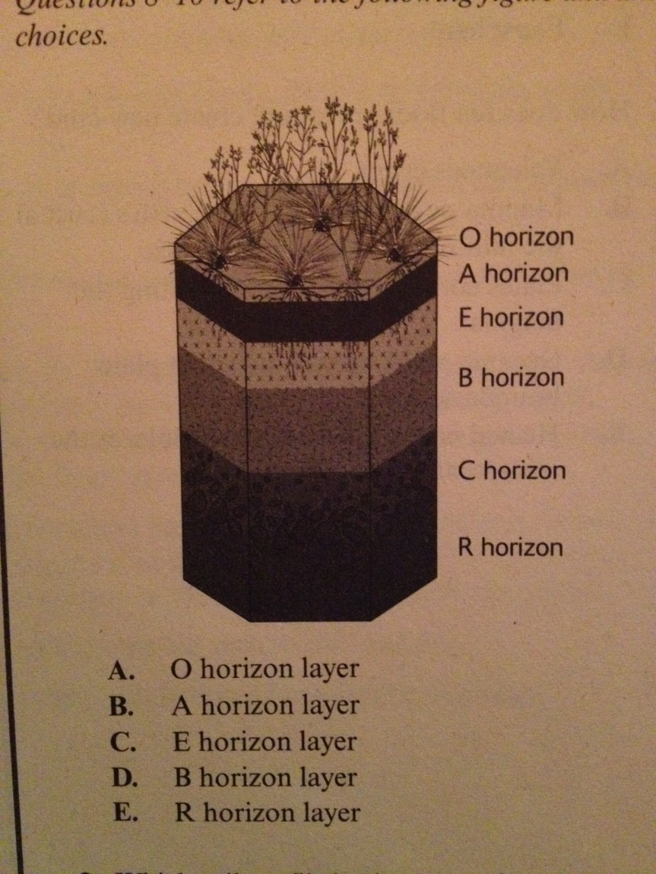
- Which soil profile horizon contains most nutrients for plant growth? _______________
- Which soil profile horizon is considered subsoil? __________________
- Which soil profile horizon is the parent material? __________________

- Compared to neutral soil, acidic soil has higher concentrations of
  - Organic matter
  - Carbon dioxide
  - Hydrogen ions
  - Ammonia
  - None of the above

