# Soil Worksheet

**Soil** is a mixture of weathered rock & organic matter that usually covers **bedrock** (solid rock that underlies all soil). Both chemical & mechanical processes are involved in the development of soils.

* Chemical weathering turns hard minerals into soft ones
* Mechanical weathering breaks solid rock into smaller pieces
* Plant & animals add organic materials in the form of waste products & dead organisms
* The decay of organic matter produces acids which accelerate chemical weathering
* Burrowing Animals, such as earthworms, insects, & rodents, help circulate air and water through the soil & mix mineral & organic remains

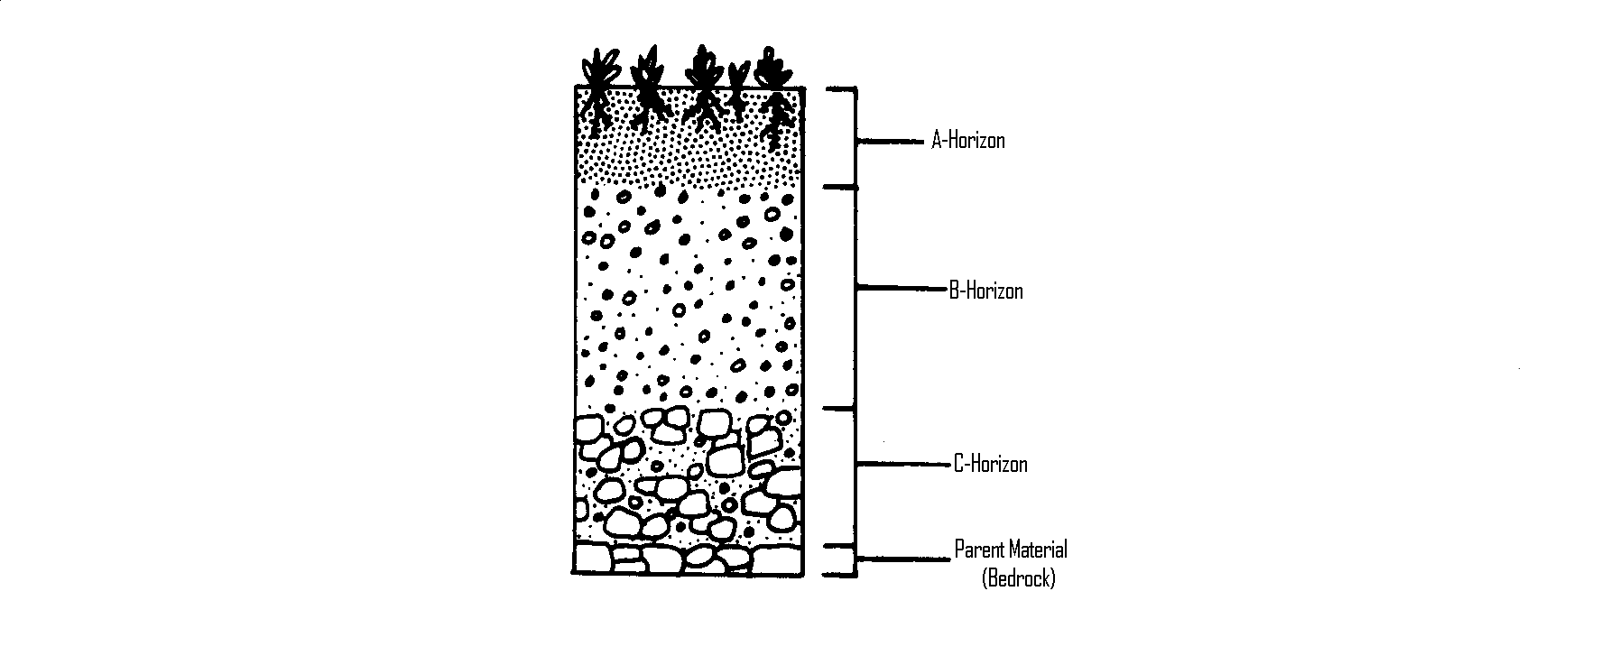The material from which soil forms is called its **parent material.** Soil that has weathered directly from the bedrock beneath it and therefore matches its parent material is called **residual soil.**

Soil that does not match the bedrock it is over is called **transported soil.** It did not weather from the bedrock beneath it but was brought there by agents of erosion such as winds, rivers, or glaciers. Much of New England & the Midwest are covered by soil that was deposited by the movement of glaciers after the last Ice Age.

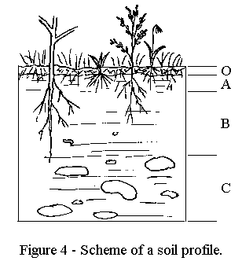A cross section of soil exposed by digging is called the **soil profile.** The weathering of soil produces layers known as **soil horizons.** The topsoil or **A horizon** is usually rich in dark-colored organic remains called **humus (labeled O horizon below)**.The subsoil or **B horizon** contains minerals that have been transported deeper by groundwater. Most of the clay in soil has also been washed down to this layer. The partially weathered bedrock or **C horizon** is composed of broken up bedrock on top of the solid bedrock (parent material).

**Soil erosion** is the removal of topsoil by the action of running water or wind. It takes between 100 & 400 years for one centimeter of topsoil to form.

Loss of topsoil can be caused when plants root are no longer present to hold down soil. Salting roads can raise the salinity of the soil and kill the plants. Over grazing can kill plants. Winds, construction, & mining can all effect plant cover.

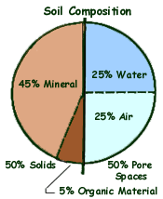

***Use the worksheet above to answer the following questions.***

1. Which layer in the diagram below contains the most organic material?

A. A B.B C.C D. the bedrock

2. How is soil created from rock?

1. physical weathering without chemical weathering
2. chemical weathering without physical weathering
3. erosion without weathering
4. weathering without erosion

3. Approximately how many years does one centimeter of topsoil take to form?

A. 100 – 400 years C. 1000 – 4000 years

B. 10 – 40 years D. 10,000 – 40,000 years

4. Which of the following is found in the greatest % in soil?

A. Mineral matter B. Organic matter C. Water D. Air

5. Which layer of a soil profile forms first from the bedrock?

A. A horizon B. B horizon C. C horizon D. humus

6. For the soil profiles below, label the horizons (A, B, or C) and the parent material in each of the soil profiles using the spaces provided next to each image.

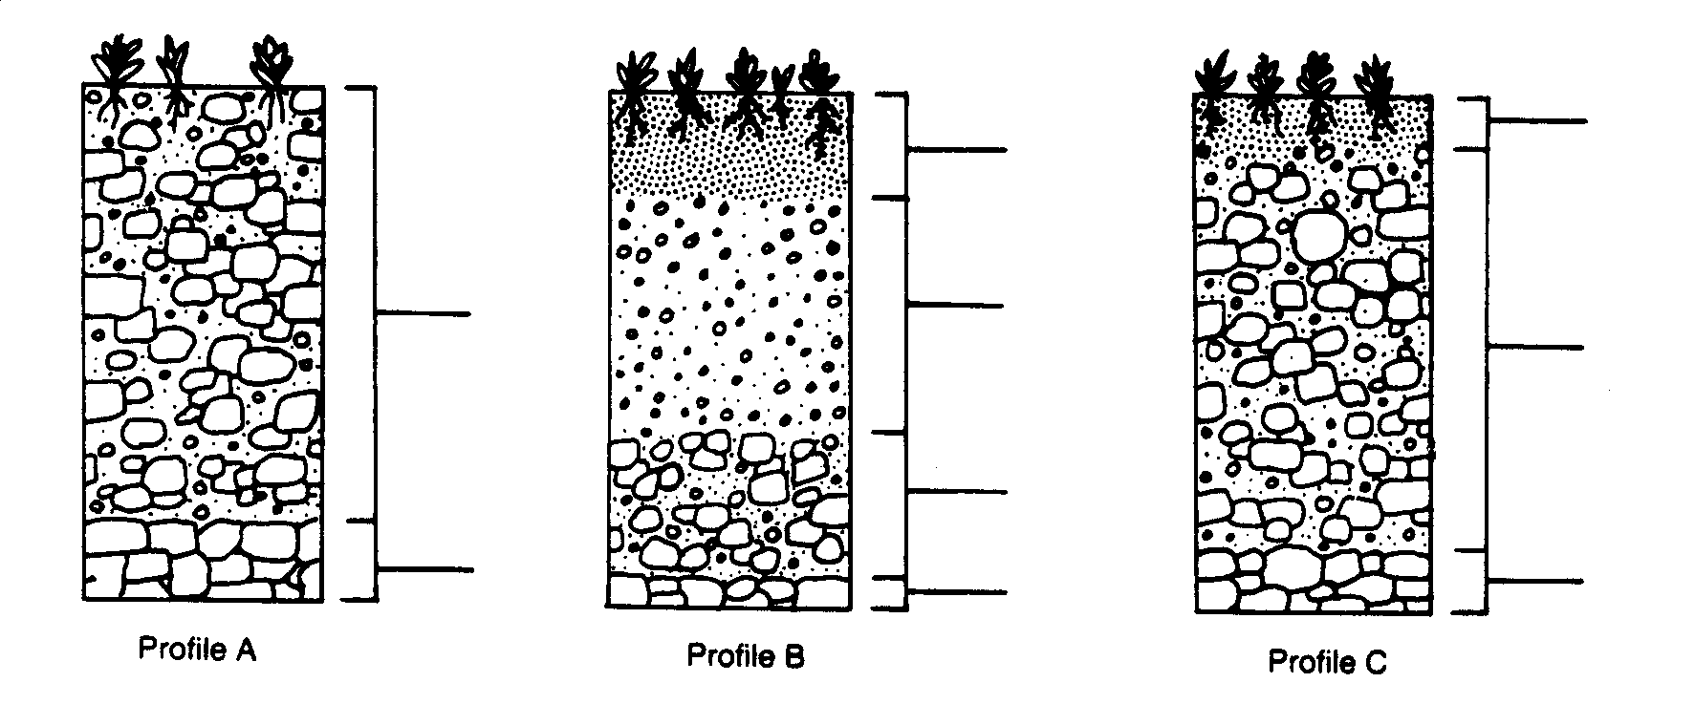

______ ______ ______

7. At the base of each profile above, number the profiles according to the proper sequence of development.

8. Match each soil profile above to the graph below that would most likely represent that profile. Write the letter of the matching profile in the space provided below each graph.

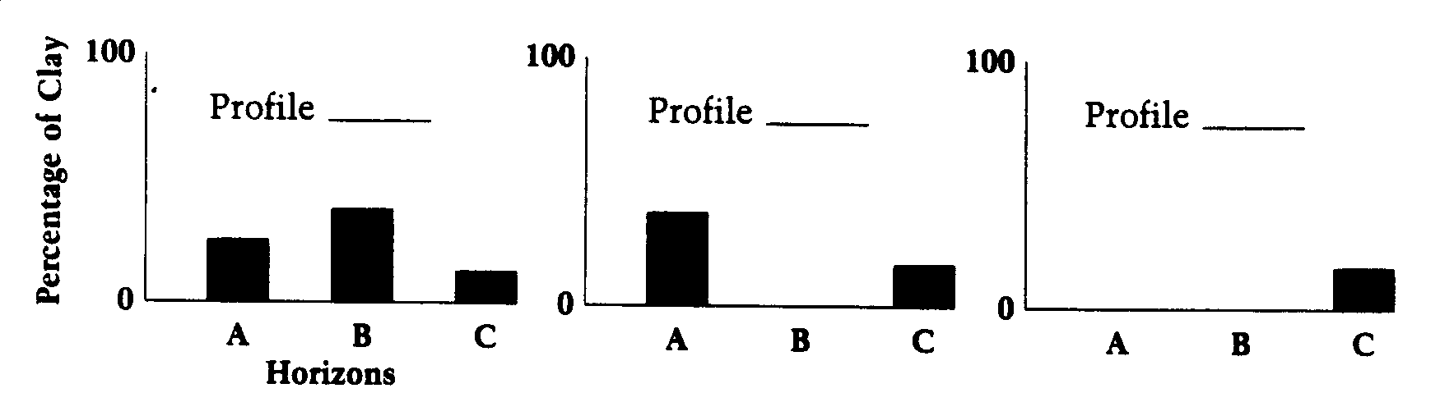

***Homework: Find one article about soil in New York State. It may be about soil quality, soil erosion, lack of good soil, etc. Write a one paragraph summary of the article IN YOUR OWN WORDS. List the source (website, author, etc.)***