Salinization Lab

According to Compass Minerals, salt is a mineral. It is made of sodium and chlorine. Salt is also known as halite. Salt is considered a crystal that is perfectly symmetrical. There are different types of salts from colorless to some are also white. There can also be shades of yellow, red, purple and blue. Today salt is used a lot in the industry. It is also used in medicine. The main use of salt is to melt ice to provide safer driving conditions. The salt melts the ice quickly. Salt is also important for humans. Sodium Allows the red corpuscles in our bloodstream to carry oxygen tissue that is vital and to get rid of the harmful carbon dioxide. Our bodies will not properly function if the ratio of salt to water is always constant. The second component of salt is chloride which is important for digestion and the bodies ability to absorb potassium. When we have less salt in our bodies, it affects the kidneys causing a salt deficiency. Symptoms of this are dizziness, hat cramp and general malaise.
According to How Salt Damages Plants, salts can be toxic for plants. When salt is dissolved in water, the ions separate. This causes the ions to replace nutrients that the plants need such as calcium and magnesium. This makes the plant unable to absorb these nutrients causing it dehydration. And unable to transport water and nutrients. eventually the plants die. While for humans this maybe good, for plants it is very hazardous. According to The Effects of Salinization On Radish Seed Germination, a lot of crops in the United States are destroyed. Plant irrigation areas are affected by salt making it very hard for regions to absorb water. If there is too much salt, the crops cannot absorb water. This causes the united states billions of dollars lost economically.
The purpose of this lab is to determine how salinization affects the germination of radish crop seeds and at what salt level concentration seeds will no longer germinate. The dependent variable is the amount of seeds germinated. The independent variable is the amount of salt. The constants are the amount of seeds, amount of water, type of salt, and type of seeds. The control is the seed grown with no salt present. The hypothesis predicted was if there is more salt, than less seeds will germinate because more water will be removed from the cells of the seeds.
Materials:
- Graduated Cylinder
- 10 mL 0% salt solution
- 10 mL 0.5% salt solution
- 10 mL 3.5% salt solution
- 3 ziplock bags
- 3 napkins
- Marker
- 30 Radish seeds
Procedure:
- Label the ziplock bags with a marker 0%, 0.5% and 3.5%.
- Place a napkin inside the bags after folding it in half.
- Place 10 seeds in every bag inside of the napkin spreading it out and then close the napkin.
- Pour amount of solution into bags based on their label.
- Observe seeds over time and record data.
Data Table:
Day | Germination in 0% salt solution | Germination in 0.5% salt solution | Germination in 3.5% salt solution
0 | 0/10 (0%) | 0/10 (0%) | 0/10 (0%)
1 | 8/10 (80%) | 3/10 (30%) | 0/10 (0%)
2 | 10/10 (100%) | 9/10 (90%) | 0/10 (0%)
3 | 10/10 (100%) | 10/10 (100%) | 0/10 (0%)
4 | 10/10 (100%) | 10/10 (100%) | 0/10 (0%)
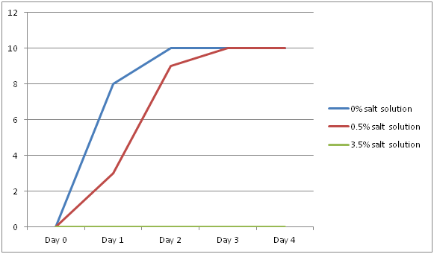
Results:
For the 0% salt solution, eight of the ten seeds germinated on the first day of recording the results. Making it 80% successful germination. By day two all ten seeds had germinated making it a 100% germination. On day three and four, the sprouts continued to grow. For the .5% salt solution, On day one, three of the seeds had germinated, making it 30% by the first day. By the second day, nine of the seeds germinated making it 90% successful germination. On day three all of the seeds were germinated, making it 100% and they continued to grow on the fourth day. For the 3.5% salt solution, no seeds had grown the first four days of check up. Making it a 0% successful germination during the full experiment time.
Discussion:
The results were expected because the seeds with 3.5% salt solution did not grow at all. This shows that salt affects plant growth by making it difficult for plant growth. The solution with no salt content germinated very quickly and reached 100% germination by the second day. This shows the difference between the salt solution and the no salt solution, concluding that salinization has a great affect on plant growth by slowing it down a lot. The .5% solution contained less salt but it showed how the seeds germinated faster than the ones in the 3.5% solution and a little slower than the no salt solution because it took three days for it to reach 100% germination. During the experiment, some errors were concluded that may have affected the results of the seed germination. For example, plastic bags were used and that could have affected the seeds space wise. In a further investigation, a suggestion is to use pots or cups. Also there was no soil used, so in another experiment, this could be tested to see whether soil would change the results in anyway. Another possible error that could have occurred is uneven distribution of water in each bag. Although a dropper was used, its possible that the water was not evenly poured in the bags and if one bag got more water than the other, it may have affected the overall results. In a further investigation, a measuring cup can be used to make sure the water distribution is even. In conclusion, the hypothesis was accurate because the more salt solution that was in the bag, the less germination occurred in it. This shows us how much difference salt makes in plant growth and negatively affects it because it slows it down. This also concludes how much loss can occur economically due to irrigation. There would be less crop yield if there is more salt in the water.

What is salt- http://www.nasalt.com/about-us/about-salt/what-salt/
How salt damages plants- https://www.extension.purdue.edu/extmedia/id/id-412-w.pdf

