AP Environmental Science
Unit 11: Energy

Name: _____________________________________________ Date:

Nonrenewable Energy Math Practice
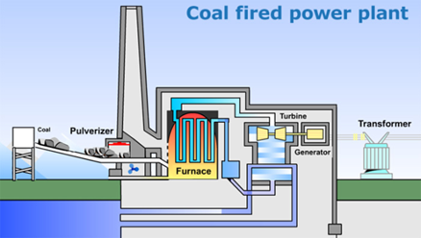
1. A large, coal-fired electric power plant produces 14 million kilowatt-hours of electricity each day. Assume that an input of 10,000 BTUs of heat is required to produce an output of 1 kilowatt-hour of electricity.

(a) Showing all steps in your calculations, determine the number of

(i) BTUs of heat needed to generate the electricity produced by the power plant each day.

(ii) pounds of coal consumed by the power plant each day, assuming that one pound of coal yields 5,000 BTUs of heat.

(iii) pounds of sulfur released by the power plant each day, assuming that the coal contains one percent sulfur by weight.

2. A small coal-fired electric power plant produces 6 million kilowatt-hours of electricity each day. Assume that an input of 10,000 BTUs of heat is required to produce an output of 1 kilowatt-hour of electricity.

(a) Showing all steps in your calculations, determine the number of

(i) BTUs of heat needed to generate the electricity produced by the power plant each day.

(ii) pounds of coal consumed by the power plant each day, assuming that one pound of coal yields 5,000 BTUs of heat.

(iii) pounds of sulfur released by the power plant each day. The coal used by this plant has not had any sulfur removed and contains five percent sulfur by weight.

3. Answer the questions below regarding the heating of a house in the Midwestern United States. Assume the following.
- The house has 2,000 square feet of living space.
- 80,000 BTUs of heat per square foot are required to heat the house for the winter.
- Natural gas is available at a cost of $5.00 per thousand cubic feet.
- One cubic foot of natural gas supplies 1,000 BTUs of heat energy.
- The furnace in the house is 80 percent efficient.

(a) Calculate the following, showing all the steps of your calculations, including units.
- The number of cubic feet of natural gas required to heat the house for one winter.
- The cost of heating the house for one winter.

