Independent vs. Dependent Limiting Factors

The amount of resources is not the only limiting factor that depends on a population’s density. Diseases and parasites can limit a population’s growth once the population reaches a certain number of organisms. The more organisms there are, the faster a disease can spread or a parasite can be transferred to another organism because there are more available hosts that are near each other. Competition for resources—either between the same species or two different species—will also decrease a population’s size. Resources are limited in any habitat, and, when populations reach a certain size, there will not be enough to go around. When two organisms in the same habitat are trying to use the same resource, they are competing for that resource. Whichever organism has the better adaptations to obtain that resource will be able to reproduce more often, and their population will grow. The organism that is not successful at competing for the resource will not reproduce as often, and their population will decrease.

Predation is another density-dependent limiting factor seen in populations. When lots of prey is available, predators will eat the prey, have energy to reproduce, and their numbers will increase. The population of their prey will begin to decrease as more and more of them are eaten. However, the predator population will eventually reach carrying capacity—there will not be enough prey for all of the predators in the population, since the predators themselves are competing for their “prey” resource. As the number of prey decreases, so will the number of predators, because there isn’t enough food to go around. As the number of predators decreases, that means the prey have time to reproduce and increase their population. Thus, predator-prey populations go through cycles of population growth, which is shown in the graph below between lynx (predator) and snowshoe hares (prey):

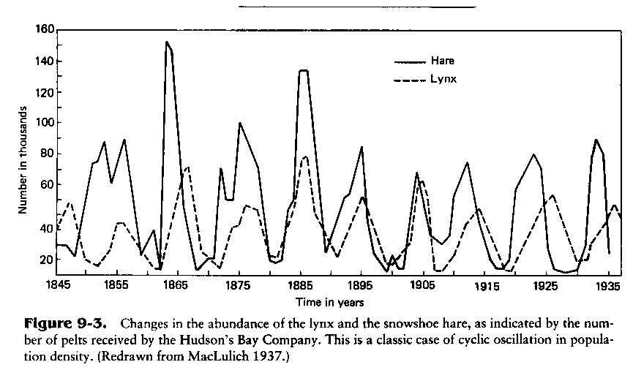

a) Pretend the graph on the previous page is the data you obtained after doing your own lab, and you are filling out the lab write-up form. You get to the part of the form where you have to fill out your results sentence. Using the data in the graph to guide you, fill out the results sentence below:
As the number of lynx increases, the number of snowshoe hares: ________________________.

b) Using what you know from the reading and from the graph, give a scientific explanation for the results sentence you completed above. (Remember: a “2” is simply repeating what’s in the reading. A “3” would involve using what’s in the reading and using the graph above as an example. A “4” would involve using what’s in the reading, using the graph above to help you explain it, and giving a new example or an analogy.)
A scientific explanation for these results is:

