Name:
The Greenhouse Gas Effect

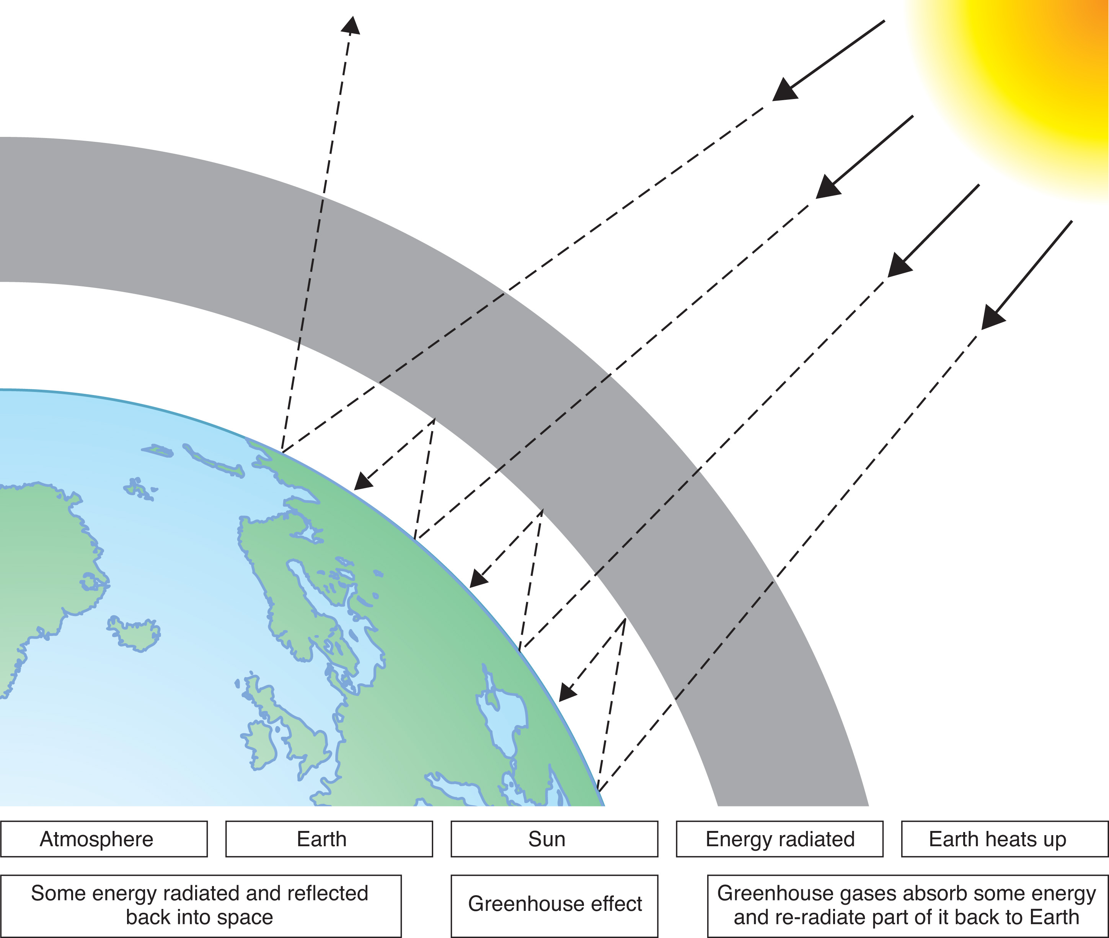

Directions: Using the image and terms above as a guide, write a paragraph that describes the greenhouse effect to an alien who is unfamiliar with the planet earth.

Homework: Short Answers to Hard Questions About Climate Change

1.) How much is the planet heating up?
1.7 degrees is actually a significant amount. As of this October, the Earth had warmed by about 1.7 degrees Fahrenheit since 1880, when tracking began at a global scale. That figure includes the surface of the ocean. The warming is greater over land, and greater still in the Arctic and parts of Antarctica.
The number may sound low, but as an average over the surface of an entire planet, it is actually high, which explains why much of the land ice on the planet is starting to melt and the oceans are rising at an accelerating pace. The heat accumulating in the Earth because of human emissions is roughly equal to the heat that would be released by 400,000 Hiroshima atomic bombs exploding across the planet every day.

2.) How much trouble are we in?
The risks are much greater over the long run than over the next few decades, but the emissions that create those risks are happening now. Over the coming 25 or 30 years, scientists say, the climate is likely to resemble that of today, although gradually getting warmer. Rainfall will be heavier in many parts of the world, but the periods between rains will most likely grow hotter and therefore drier. The number of hurricanes and typhoons may actually fall, but the ones that do occur will draw energy from a hotter ocean surface, and therefore may be more intense, on average, than those of the past. Coastal flooding will grow more frequent and damaging.
Longer term, if emissions continue to rise unchecked, the risks are profound. Scientists fear climate effects so severe that they might destabilize governments, produce waves of refugees, precipitate the sixth mass extinction of plants and animals in Earth’s history, and melt the polar ice caps, causing the seas to rise high enough to flood most of the world’s coastal cities.
All of this could take hundreds or even thousands of years to play out, conceivably providing a cushion of time for civilization to adjust, but experts cannot rule out abrupt changes, such as a collapse of agriculture, that would throw society into chaos much sooner. Bolder efforts to limit emissions would reduce these risks, or at least slow the effects, but it is already too late to eliminate the risks entirely.

3.) Is there anything I can do?
There are lots of simple ways to reduce your own carbon footprint, and most of them will save you money. You can plug leaks in your home insulation to save power, install a smart thermostat, switch to more efficient light bulbs, turn off the lights in any room where you are not using them, drive fewer miles by consolidating trips or taking public transit, waste less food, and eat less meat.
Perhaps the biggest single thing individuals can do on their own is to take fewer airplane trips; just one or two fewer plane rides per year can save as much in emissions as all the other actions combined. If you want to be at the cutting edge, you can look at buying an electric or hybrid car, putting solar panels on your roof, or both.
If you want to offset your emissions, you can buy certificates, with the money going to projects that protect forests, capture greenhouse gases and so forth. Some airlines sell these to offset emissions from their flights, and after some scandals in the early days, they started to scrutinize the projects closely, so the offsets can now be bought in good conscience. You can also buy offset certificates in a private marketplace, from companies such as TerraPass in San Francisco that follow strict rules set up by the state of California; some people even give these as holiday gifts. Yet another way: In states that allow you to choose your own electricity supplier, you can often elect to buy green electricity; you pay slightly more, with the money going into a fund that helps finance projects like wind farms.
In the end, though, experts do not believe the needed transformation in the energy system can happen without strong state and national policies. So speaking up and exercising your rights as a citizen matters as much as anything else you can do.

4.) What’s the optimistic scenario?
In the best case that scientists can imagine, several things happen: Earth turns out to be less sensitive to greenhouse gases than currently believed; plants and animals manage to adapt to the changes that have already become inevitable; human society develops much greater political will to bring emissions under control; and major technological breakthroughs occur that help society both to limit emissions and to adjust to climate change.
The two human-influenced variables are not entirely independent, of course: Technological breakthroughs that make clean energy cheaper than fossil fuels would also make it easier to develop the political will for rapid action.
Scientists say the odds of all these things breaking our way are not very high, unfortunately. The Earth could just as easily turn out to be more sensitive to greenhouse gases than less. Global warming seems to be causing chaos in parts of the natural world already, and that seems likely to get worse, not better. So in the view of the experts, simply banking on a rosy scenario without any real plan would be dangerous. They believe the only way to limit the risks is to limit emissions.

Answer the following questions in two paragraphs:
- What did you find the most surprising about this article? Why?
- What did you find the least surprising about this article? Why?

