Name:
Date:

GMO Label Essay

Prompt: Should we label GMOs?

Your essay should include
- Introduction
- Two claims
- One counterclaim
- Conclusion

Essay checklist:
- Did you provide a clear position in the introduction paragraph?
- Do you have two clear claims supported with evidence from the text?
- Did you include analysis?
  - Ex: why is claim this important? What are some of the broader implications? How does it relate back to your position?
- Did you include a counterclaim?
  - Do you include evidence from the text to represent the opposing side AND include evidence when you refute the counterclaim?
  - Do you have a strong conclusion?

Due: Mon. Feb. 22nd

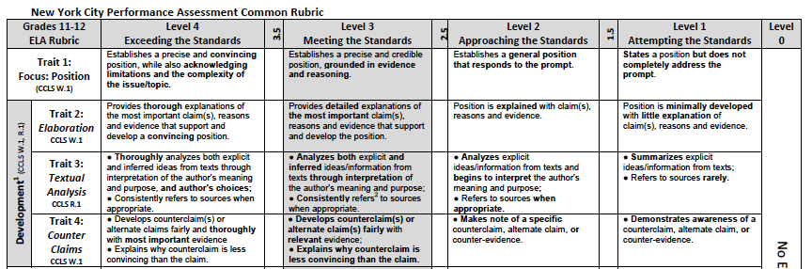
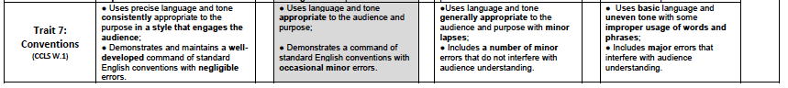

Conclusion:

Strengthening:

Counterclaim:

Evidence:

Refutation of counterclaim:

Evidence:

Claim:

Evidence:

Analysis:
Claim:

Evidence:

Analysis:
Background info on GMOs:

Position:

