To read the food web: The arrows show what each organism eats and the flow of energy. The arrow points to the organism that does the eating and who GETS the energy. Ex: the snowy owl eats the artic hare and the lemming. The owl gets its energy from the hare and the lemming.

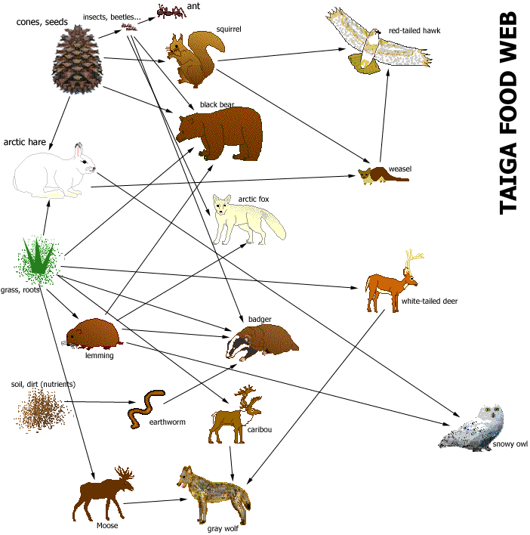

Bacteria, dead organisms in soil

Decomposer—Organism that gets food by breaking down dead organisms into small molecules.
Herbivores—An organism that eats only plants.
Carnivore—An organism that eats only other animals.
Omnivore—An organism that eats both plants and animals.
Reading a Food Web
DIRECTIONS: Use the “Taiga Food Web” to answer the questions.
- Badgers eat __________________________________________________________________.
- Wolves eat __________________________________________________________________.
- Bears eat ____________________________________________________________________.
- Owls eat ____________________________________________________________________.
- Deer eat ____________________________________________________________________.
- Ants eat _____________________________________________________________________.
- Categorize ALL the organisms in the food web. Use the definitions to help.
Decomposer Herbivore Carnivore Omnivore
Squirrel

- Cones and seeds get eaten by ____________________________________________________.
- Weasels get eaten by __________________________________________________________.
- Lemmings get eaten by ________________________________________________________.
- Moose get eaten by ____________________________________________________________.
- Predict what would happen to the ecosystem if all the insects and beetles died.
The number of ants would ___________________________________________________.
The number of seeds and cones would __________________________________________.
The number of bears would __________________________________________________.
- Predict what would happen to the ecosystem if all the black bears died.
______________________________________________________________________________
_______________________________________________________________________________
_______________________________________________________________________________
_______________________________________________________________________________

