Cemetery Lab

Vocab:

Demography:

Mortality:

Introduction
Local cemeteries are an excellent place to study human demography. Etched in the gravestones are the dates of birth and death of the person below, at least in most cases. From these data, we can calculate death rates and draw survivorship curves. A survivorship curve is simply a graphical representation of the chance that an individual will survive from birth to any particular age. Different cemeteries may represent different socio-economic cross-sections of the population, and comparing data among cemeteries may reveal different patterns of mortality.

Over the last few centuries, advances in health care and large-scale global political conflict have left rather opposing marks on the demographics of the U.S. population. Two major time intervals stand out: before 1950 and from 1950 to the present. Firstly, the time interval before 1950 includes the Industrial Revolution, the ravaging effects of polio, the 1918 influenza pandemic, infections and other presently curable diseases, as well as World Wars I and II. Following 1950, numerous vaccines and antibiotics were widely used and, with the exception of the Korean, Vietnam, and Gulf Wars (not to mention a few other incidents...), this has been an era of relative peace in North America. However, new pandemics have emerged such as AIDS and SARS. What are your predictions about how the demographics of the United States population have changed during these two time periods?

Type 1 (Late Loss survivorship curve):

Type 2 (Constant loss survivorship curve):

Type III Early Loss Survivorship Curve:

Prediction Before 1950:

Prediction After 1950:

Complete the following table using the cemetery data provided. The males Pre-1950 data have been completed for you

- In the number of deaths column, record the number of deaths for each age category
- Calculate the survivorship for each age category.
  - For each column, enter the total number of individuals in the study (30) in the 0-9 survivorship cell. This is the survivorship for the 0-9 age group.
  - Subtract the number of deaths at age 0-9 from the survivorship value at age 0-9. This is the survivorship at the 10-19 age category.
  - To calculate the survivorship for age 20-29, subtract the number of deaths at the age 10-19 age category from the survivorship value for age 10-19. Continue until you have completed the column.

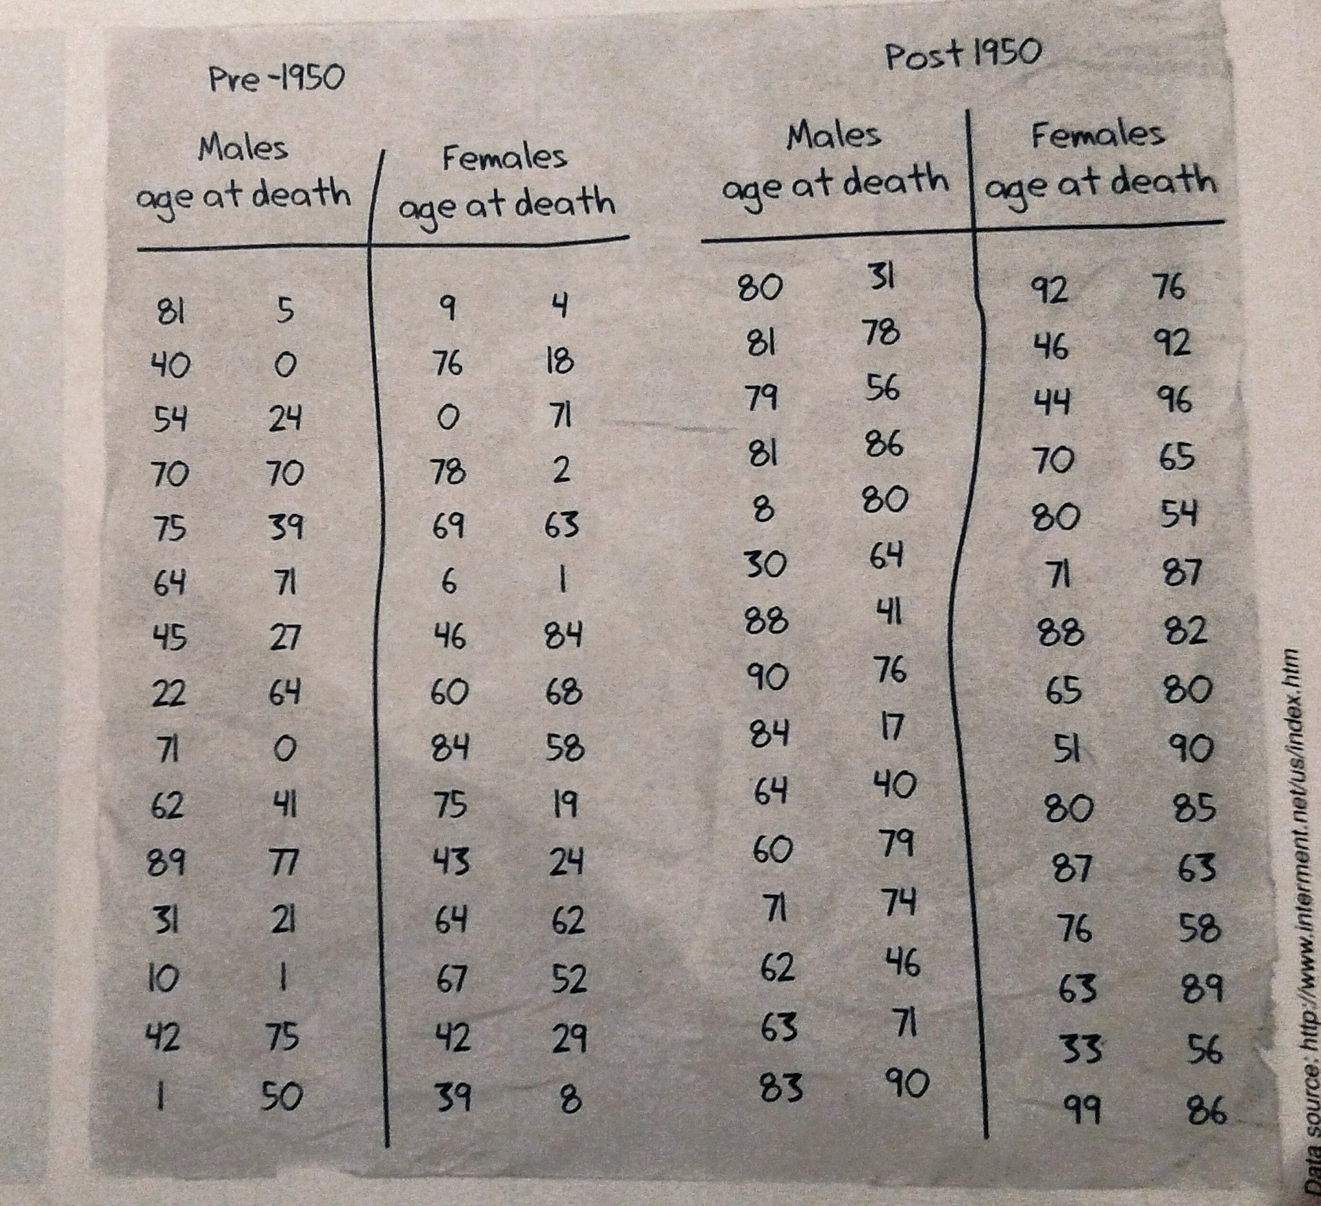
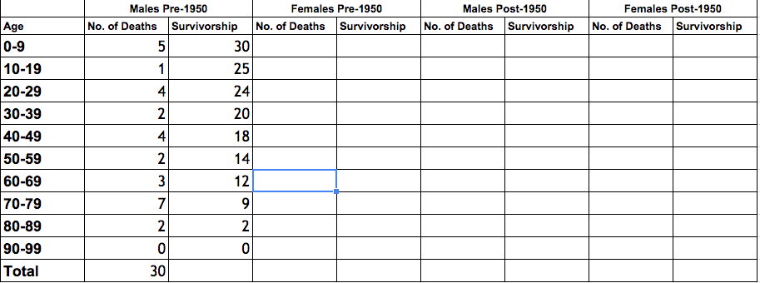

- On a separate piece of graph paper, make a graph for the pre-1950 data and a graph for the post-1950 data
Don’t forget to..
- Plot the female and male data for each time period on the SAME graph
- Create an appropriate scale
- Place the survivorship number on the y axis and the age on the x axis
- Create a title and a key

- What conclusions can you make about survivorship before 1950 and after 1950?

- What factors might cause these differences?

