Carrying Capacity Homework

Directions: Answer all questions in COMPLETE SENTENCES

- Write your own definition of carrying capacity:

- Refer to the following statement when answering the next questions.
“ The carrying capacity of this lake equals 150 minnows”
- Can less than 150 minnows live in this lake? Why or why not?

- Can more than 150 minnows live in this lake? Why or why not?

- Imagine that there are 140 minnows in this lake when the amount of resource sin this lake decreases and the carrying capacity drops from 150 to 100 minnows. What will happen to this minnow population? Why will this happen?

2) Refer to the following graphs for the next set of questions

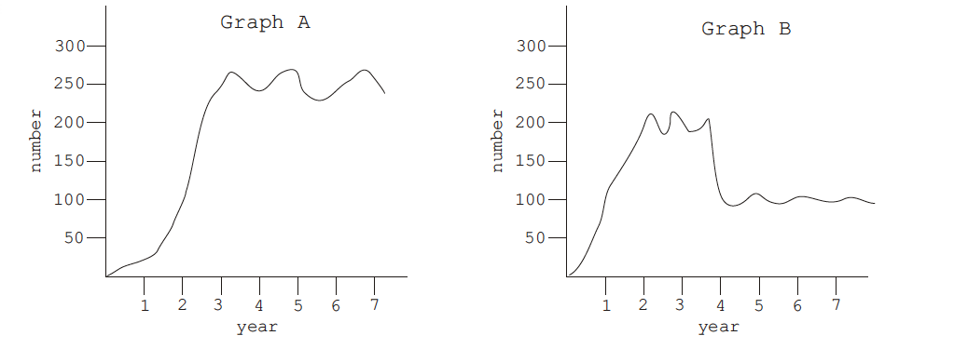

For Graph A:
- What is carrying capacity?_______________________
- During approximately which year did this population reach the carrying capacity of its ecosystem?______________________
- About how many years did it stay at carrying capacity?______________________________

For Graph B:
- What are the carrying capacities of this graph?

- How many years did the population spend at the first carrying capacity?

- During which year did it reach the next carrying capacity?

- Which carrying capacity is more stable? Why do you think so?

