Carrying Capacity

Directions: Refer to the graph below to answer the questions in COMPLETE SENTENCES.
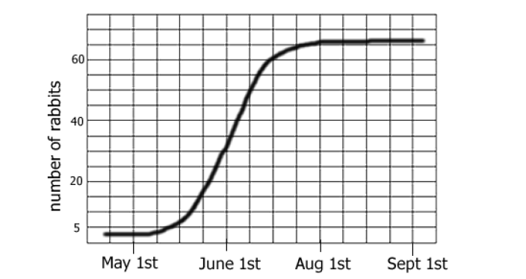

- What is the rabbit population’s carrying capacity? ____________

- During what time frame is the population of rabbits growing the fastest?

- What type of population growth is represented during the time frame you mentioned in question 2?

