The Biosphere

Directions: Look at the picture below and identify the parts that are the biosphere, lithosphere, and atmosphere (they may be visible or not visible). For each organism listed in the picture, identify how it interacts with one other sphere or how it interacts with another organism in the biosphere.

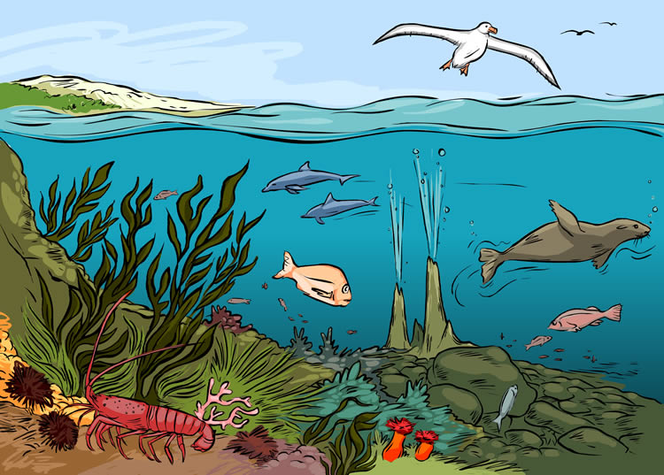

Atmosphere:___________________________________________________________
Lithosphere:___________________________________________________________
Biosphere:_____________________________________________________________

Organism Interaction
Gull

Seaweed

Seal

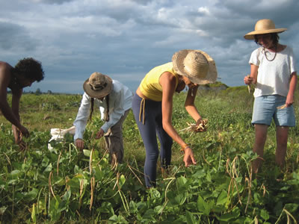

Atmosphere:____________________________________

Lithosphere:______________________________________

Biosphere:__________________________________________

Organism Interaction
Bean plant

Humans

Earth worms in the soil

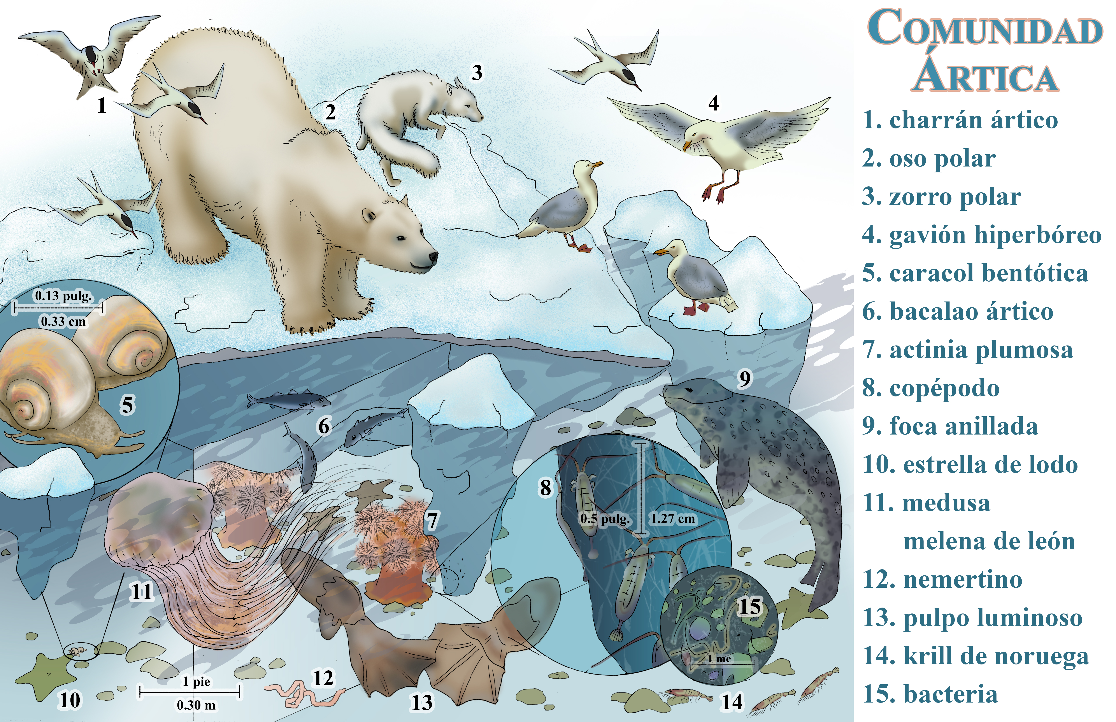
Atmosphere:_____________________________________

Lithosphere:_____________________________________

Biosphere:_______________________________________

Organism Interaction

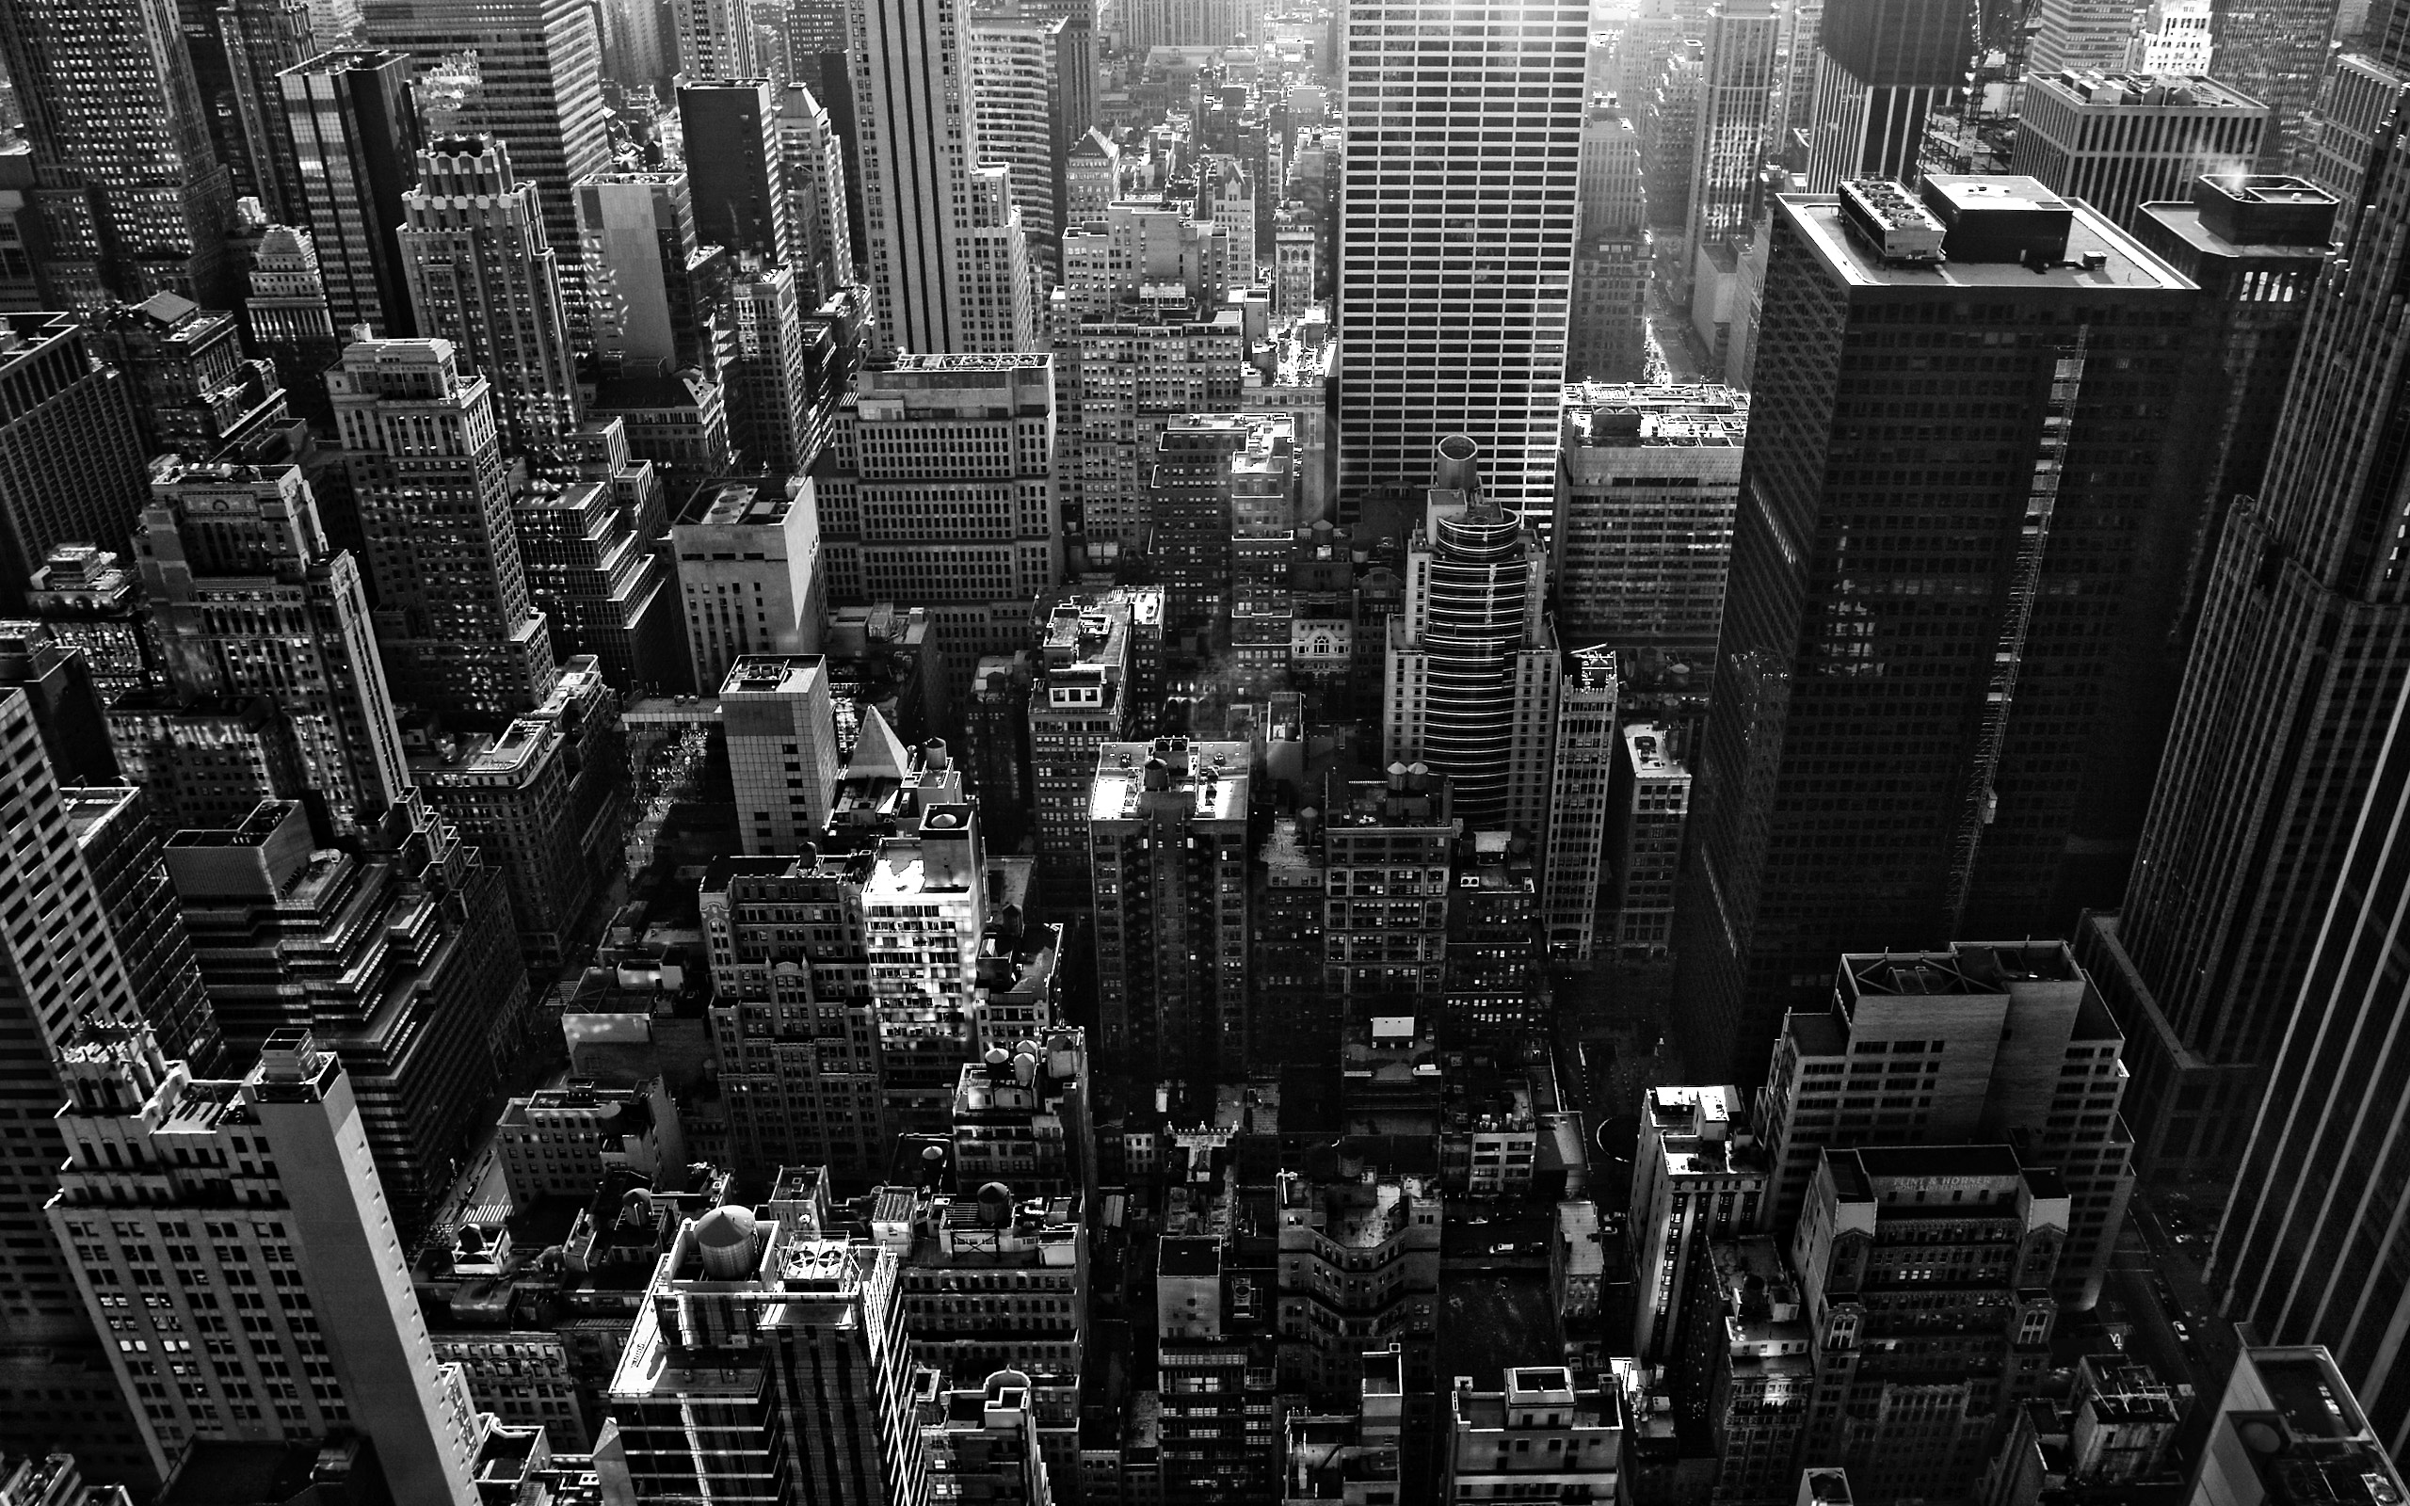

Atmosphere:____________________________________

Lithosphere:____________________________________

Biosphere:_______________________________________

Organisms in NYC Interactions

