URBAN ASSEMBLY SCHOOL FOR CRIMINAL JUSTICE

4200 16th Avenue, Brooklyn, New York 11204

Phone: (718) 438 – 3893

MARIELA GRAHAM, Principal

Nathalie Jufer, Assistant Principal

A.P. Environmental Science

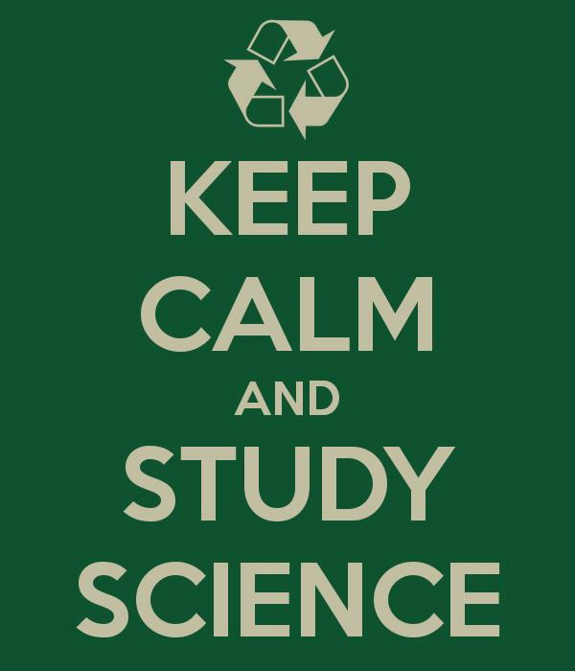

2015-2016

Teacher: Ms. McDaniel
Email: kmcdaniel@uascriminaljustice.org
Class Website:
http://uascjmcdaniel.weebly.com

Welcome to A.P.E.S.!
The Planet Earth is in grave danger. In order to make informed decisions, it is crucial for the world’s citizens to have a broad knowledge of environmental problems. The College Board created the AP Environmental Science course with the intention of providing students with the scientific principles, concepts, and methodologies required to understand the interrelationships of the natural world, to identify and analyze environmental problems both natural and human-made, to evaluate the relative risks associated with these problems, and to examine alternative solutions for resolving and/or preventing them. A.P. environmental science is an interdisciplinary study that integrates information from both natural sciences (biology, chemistry, earth science, physics) and social sciences (economics, ethics, politics).

Course Goals: We will ALL
- Write college-level lab reports
- Score a 4 or 5 on the A.P. exam on Monday May 2nd at 8 a.m.

Major Unifying Themes:
- Earth is an interconnected system
- Humans alter natural systems
- Survival depends on sustainable systems

Textbook: Freidland and Reylea. Environmental Science for the A.P. 2012

Course outline:
Unit | Text Reference | Activity/Lab | Duration
Introduction to Environmental Science | Ch.1, Ch. 2 | Inquiry lab: Fertilizer.  Lab: What is energy? | 2 weeks
Ecology and Biodiversity | Ch. 3, Ch. 4, Ch. 5 | Inquiry lab: nitrogen cycle  Lab: Benthic Bugs  Field lab: Aquatic invertebrates pond survey  Activity: Determining the health of a pond ecosystem  Sugar Babies Lab  Outdoor Albedo Lab  Ice cube density lab  Jellybean Evolution | 4 weeks
Population and Conservation Biology | Ch. 6, Ch. 18 | Lab: Catch and release  Virtual Lab: Succession  Activity: Forest Succession  Project: Invasive Species News Article  Lab: Island Biogeography | 3 weeks
Water | Ch. 9, Ch. 14 | Inquiry lab: Waste Water Treatment  Lab: Water Quality | 2 weeks
Geology: Processes and Soil | Ch. 8 | Lab: Soil Properties  Activity: Cookie Mining | 2 weeks
More humans, More problems | Ch. 7, Ch. 20 | Video: NOVA population in the balance  Human population growth lab  Activity: Cemetery Survivorship curves  Research paper: Solutions to human population growth | 2 weeks
Global Climate Change | Ch. 19 | Lab: analysis of carbon dioxide  Activity: Grappling with graphics | 2 weeks
Land and Food | Ch. 10, Ch. 11 | Project: Origins of food  Film: Food INC.  Activity: Estimating Carrying Capacity  Inquiry lab: Salinization  Lab: nitrogen fixation fertilizer  Lab: Energy transfer | 2 weeks
Air | Ch. 15 | Inquiry lab: Air Quality  Lab: Acid Rain | 1 week
Waste and Toxicity | Ch. 16, Ch. 17 | Project: Waste Diary  Lab: Virustown  Project: Waste Diary  Lab: LD50 | 2 weeks
Energy | Ch. 12, Ch. 13 | Film: A crude awakening: The Oil Crash  Lab: Making biodiesel from new vegetable oil  Lab: Radiation on the effect and germination of radish seeds | 3 weeks

Materials
The following items are required for this class. Please have all of these items by Wednesday, September 16th.

- 1 inch or 1.5 inch binder
- College ruled loose leaf paper
- 1 composition notebook for labs
- 1 spiral notebook for Current Events Journal
- Pen or pencil

Grading Policy
Tests, Quizzes, Labs, Projects and Papers | 80%
Homework | 10%
Participation | 10%

My expectations of you in this class

Entry routine: When you enter the classroom, you should do these three things immediately:
- Take out your binder
- Take out any homework from the night before and place it at the top of the table
- Write down the objective and start on the Do Now.

In-Class Behavior: During lectures be attentive and ask questions. If you have a question, raise your hand! Do NOT call out. It is rude and will get you thrown out of class in college.

Do Now: Do Nows will either consist of A.P. multiple-choice questions. You should keep the Do Now multiple choice questions as they may show up on exams.

Homework: You should spend at least an hour studying/reading for this class EVERY night. As you read you should take notes. Possible note-taking strategies include:
- Cornell Notes
- Write down definitions (in bold)
- Summarize “Key Ideas Revisited”
Additional homework assignments include FRQs, news articles, research papers graphing and math worksheets. Reading notes may randomly be collected and counted as quiz grades.

Current Event Presentations: Currents events in environmental science frequently pop up on FRQs. Every student will be giving a 10 minute presentation on a current event (within the last 5 years) that relates to their assigned unit. The exact dates for each presentation will be decided at the beginning of the each unit. All presentation topics must be approved by Ms. McDaniel beforehand.
Unit | Student Presenters
Ecology and Biodiversity | - Rimsha  - Amrat
Population and Conservation Biology | - Desire  - Monica
Water | - Mehrangiz  - Shayna
Geology: processes and soil | - Harmanpreet  - Cynthia
More humans, more problems | - Hamna  - Rahila
Global Climate  Change | - Uzma  - Bukurie
Land and Food | - Wyllana  - Mahnoor
Air | - Attia
Waste and Toxicity | - Wendy  - Saliha
Energy | - Kaylah  - Ramlah

Current Event Journals: Your current event journal will contain summaries from current event presentations and from articles that I assign as homework. The journal will randomly be collected and the entries will count as a quiz grade.

Absent/ late work: If you are absent, it is YOUR responsibility to make up the work within 2 days in order to receive full credit. This policy holds true for exams, quizzes and labs. You can find copies of power points presentations, class worksheets, and homework on the class website or in the absent folder. You MUST write absent at the top of the assignment so that it is not counted as late. For lab reports, essays and projects, you must include a signed note from home in order to receive full credit. The maximum grade that late work can receive is 75%. Once a unit has ended, you cannot turn in work for that unit.

Extra Help
If you need extra help on assignments you may come in any day during lunch. If you wish to meet with me before school or after school, please talk to me beforehand so we can schedule a time.

Exams: You will have an exam for every unit that will consist of 50 multiple-choice questions. In later units, exams will occur on block days with 50 multiple choice questions and two FRQs. There will be a midterm and final exam for this class.

Quizzes: The frequency of quizzes will vary depending on the unit. For longer units, there will be more quizzes. Quizzes may consist of vocab definitions, multiple choice questions, or math problems.

The A.P. Exam
This course is equivalent to a one semester introductory course in environmental science. In order to receive college credit, you must pass the A.P. exam.

Exam Topics:
Earth Systems and Resources 10-15%
(earth science, atmosphere, global water resources, soil)
Living World 10-15%
(Ecosystem structure, energy flow, ecosystem diversity, natural ecosystem change biogeochemical cycles)
Population 10-15%
(population biology, human population)
Land and Water Use 10-15%
(Agriculture, forestry, mining, fishing, global economics)
Energy Resources and Consumption 10-15%
(energy concepts, energy consumption, fossil fuel resources, nuclear energy, hydroelectric power, energy conservation, renewable energy)
Pollution 25-30%
(air pollution, noise pollution, water pollution, solid waste, impacts on the environment and health, economic impact)
Global Change 10-15%
(stratospheric ozone, global warming, loss of biodiversity)

Exam Format: The exam is divided into two parts:
Part I:
100 multiple choice questions (90 minutes)
Breadth and knowledge of content (60% of final score)

Part II:
4 free response questions (90 minutes)
Critical thinking and application of concepts (40% of final score)
1 data set question, 1 document-based question, 2 synthesis and evaluation question

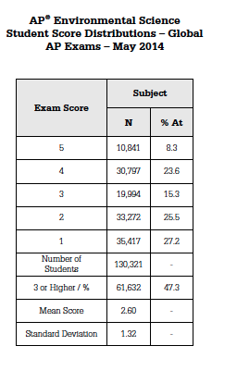

Think/Pair/Share:
What are two thoughts or reactions you have to this data?

Strategies to succeed in this class:
- Review notes from class every night
- Keep up with current events in environmental science
- Make flash cards
- Find study buddies!

Dear Parent/Guardian,

My name is Kayla McDaniel and I am your daughter’s A.P. environmental science teacher this year. I selected your daughter to be in this course because she performed well in my environmental science class last year and has a strong work ethic. This is a rigorous, college-level science course that includes a considerable amount of homework and studying.

Please take a moment to fill out your contact information. One of my goals this year is to establish and maintain consistent communication with parents.

Parent/guardian name: __________________________________

Student’s name:___________________________________

Cell Phone:________________________________________

Home Phone:________________________________

Email:_________________________________________

Best way to reach you:_____________________

Does your daughter have access to a computer at home?_______

Does your daughter have access to internet at home?_________

Parent signature:___________________________________________________

Please be aware that the following are required materials for my class:
- 1 inch or 1.5 inch binder
- College ruled loose leaf paper
- 1 composition notebook for labs
- 1 spiral notebook for current events articles
- Pen or pencil

Students must have these materials by Wednesday, Sept. 16th.

Please feel free to reach out to me with any questions or concerns!

Sincerely,
Kayla McDaniel
Email: kmcdaniel@uascriminaljustice.org

