Air Pressure

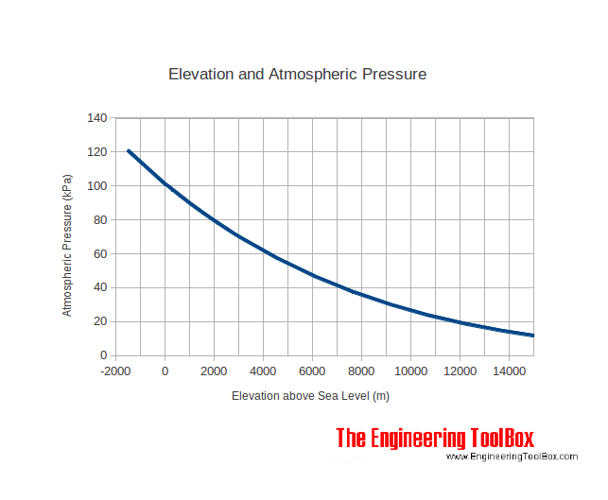

- In the graph above, what is the independent variable?

- What is the dependent variable?

- Write a trend based on the graph:

Directions: Answer the following questions in COMPLETE sentences

- Arooj is standing on top of the empire state building and Alison is at the beach at Coney Island. Who is experiencing more air pressure? Why?

- At which location is there higher air density? Why?

- Efuru is on the second floor of her apartment building and Anam is at the bottom of a 10 foot hole. Who is experiencing more air pressure? Why?

- At which location is there lower air density? Why?

******Homework***********
Research the following information about Mt. Everest:
Elevation:_________________

Total number of people who have successfully climbed to the top:___________________

The elevation at which people need oxygen:________________________

Source (Website name and URL):

